**BEAN VOYAGE CAFE WEBSITE**

**PROJECT REPORT**

***Submitted By***

**GROUP NO.22-A PROJECT GROUP NO. 3**

**JASNOOR SINGH. 2310991942**

**JAY SONI. 2310991943**

**JYOTI DHAMIJA. 2310991944**

in partial fulfilment for the award of the degree

*of*

**BACHELOR OF ENGINEERING**

in

**COMPUTER SCIENCE & ENGINEERING**



**CHITKARA UNIVERSITY**

**CHANDIGARH-PATIALA NATIONAL HIGHWAY RAJPURA (PATIALA) PUNJAB-140401 (INDIA)**

## Abstract

This project involves the development of a frontend for a café website using HTML and CSS. The objective is to create an engaging and visually appealing online presence for the cafe, enhancing its digital representation and customer interaction. Through a user-friendly interface, customers can explore an extensive menu, customize their orders, and seamlessly place them for pickup or delivery. The report outlines the cafe’s background, the technologies employed (HTML and CSS), and the design considerations implemented to achieve a seamless user experience.

Table Of Contents

|  |  |  |
| --- | --- | --- |
| Sr. no. | Section | Pg. no. |
| 1. | Introduction | 1 |
| 2. | Problem Statement | 2 |
| 3. | Technical Details | 3 |
| 4. | Key Features | 4 |
| 5. | Project Advantages | 5 |
| 6. | Result | 6 - 7 |
| 7. | Conclusion | 8 |

**Introduction**

In the ever-evolving landscape of consumer experiences, the traditional coffeehouse, once synonymous with cozy corners and aromatic brews, is embracing a new era of innovation. Enter the "Tech Bean Voyage Cafe" – a conceptual cafe website that seeks to seamlessly blend the timeless allure of a coffeehouse with the cutting-edge possibilities afforded by modern technology.

**Problem Statement**

Design an intuitive and visually appealing interface that not only showcases the café's offerings but also creates a virtual ambiance reflective of the in-person experience. Ensure optimal responsiveness across different devices to cater to a diverse audience.

**Technical Detail**

Standard web technologies used to create this calculator are-

**HTML**= HTML stands for Hyper Text Markup Language. It is used to create structure of a web page. It serves as backbone of web pages.

**CSS**= CSS stands for Cascading Style Sheet.CSS is responsible for styling and formatting the visual appearance of web pages.

**JavaScript**=JavaScript (JS) is a cross-platform, object-oriented programming language used by developers to make web pages interactive. It allows developers to create dynamically updating content, use animations, pop-up menus, clickable buttons, control multimedia, etc.

**Key Features**

• Interactive Menu: The website features an interactive menu, allowing users to explore the cafe's offerings with detailed descriptions and images, enticing them to discover the diverse range of culinary delights.

• Location and Contact Information: Users can easily find the cafe's location and contact details, fostering a convenient means for customers to plan their visit or get in touch with inquiries.

• Aesthetic Design: The use of CSS contributes to an aesthetically pleasing design, reflecting the cafe's ambiance and creating a visually engaging online representation.

In conclusion, this front-end project not only enhances the online presence of the cafe but also prioritizes a positive user experience through the seamless integration of HTML and CSS, making it an invaluable asset for the cafe's digital strategy.

**Project Advantages**

* Enhanced User Experience: The website's intuitive design and easy navigation contribute to an enhanced user experience, allowing customers to explore the cafe's offerings effortlessly.
* Responsive Design: Utilizing responsive web design principles ensures that the website adapts seamlessly to various devices, providing a consistent and visually pleasing interface across desktops, tablets, and mobile phones.
* Increased Accessibility: The website serves as a valuable tool for the cafe to connect with a broader audience, allowing potential customers to access information about the cafe from the comfort of their homes.
* Mobile Responsiveness: The website is optimized for different screen sizes, catering to the increasing number of users accessing websites on mobile devices.

The Cafe Connect website offers several advantages. Firstly, it serves as an online brochure, providing potential customers with a virtual tour of the cafe's ambiance. Secondly, the website includes a detailed menu with vivid descriptions of each item, facilitating informed choices. Lastly, it establishes a direct line of communication through contact forms and social media links, fostering a sense of community among patrons.

## RESULT

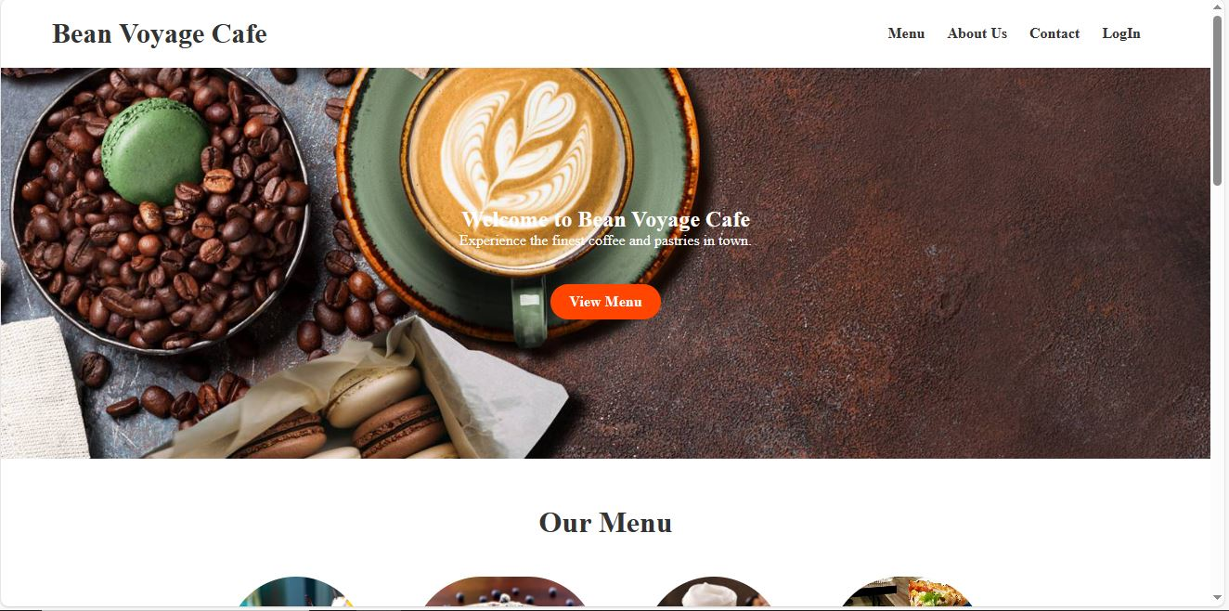

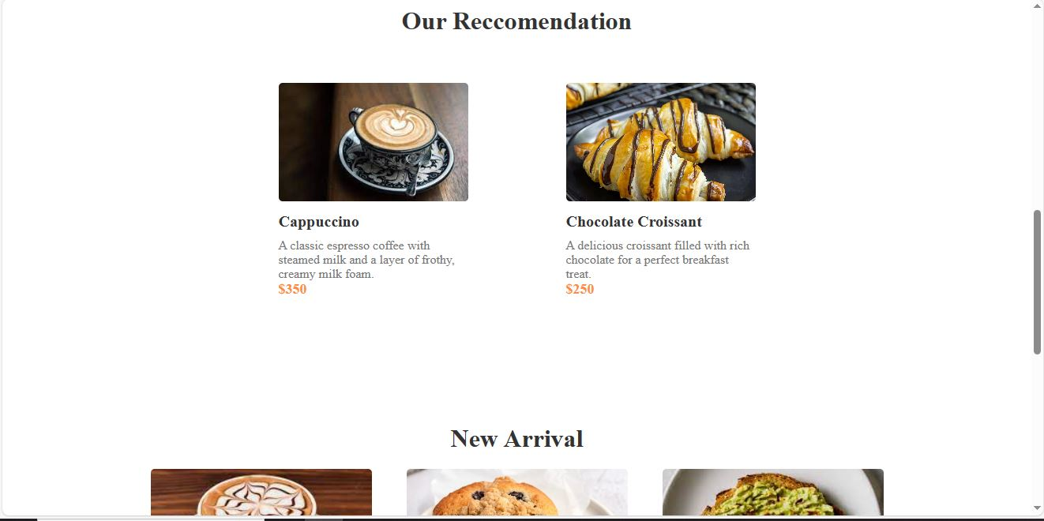

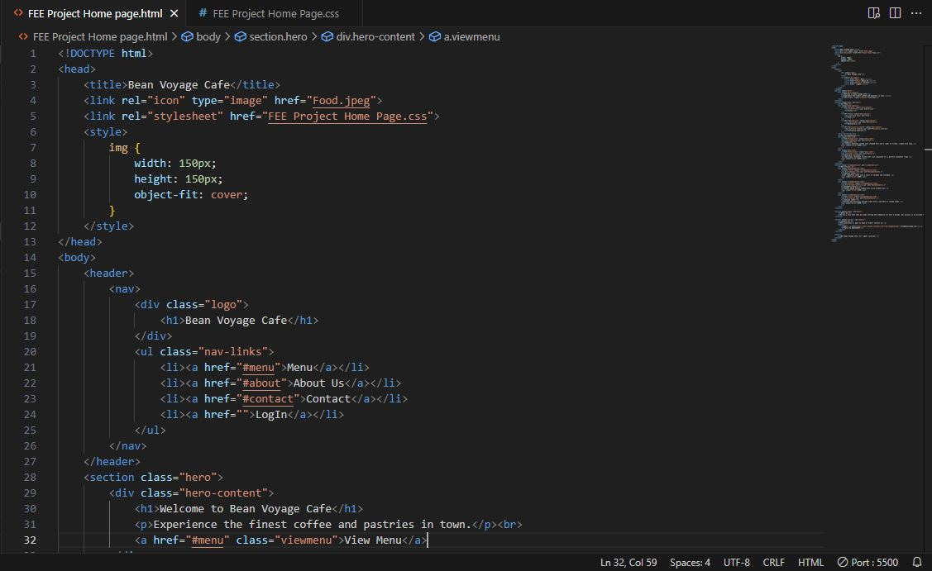

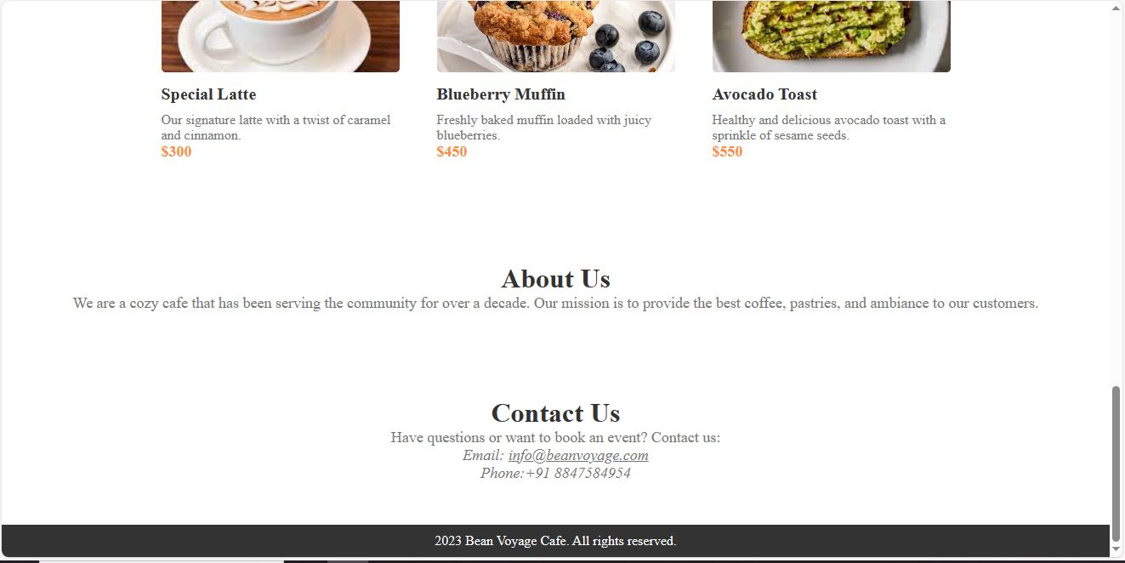

**Conclusion**

The completion of the frontend development for Java Junction's website marks a significant step in establishing a strong online presence. The use of HTML and CSS has enabled the creation of a visually appealing and functional platform that aligns with the café's brand identity.